Before you begin building your resume with the help of ChatGPT, there are two aspects of prompt engineering we need to understand:-

- Role Prompting: Telling ChatGPT to assume the role of a career coach, resume writer, or a professional with over 20 years of experience in the relevant field helps ChatGPT adopt the persona of an expert, and provide more accurate responses in comparison to generic ones.

- Chain of Thought Prompting: This technique asks ChatGPT to generate a series of intermediate steps to arrive at the final response, which results in higher quality responses. ChatGPT isn’t great at solving complex problems, and using single prompts will never do. Instead, we must use a series of smaller prompts.

Now, let’s dive into the step-wise prompts we can use to build our resume. We have 6 steps in total as per our research. Check out the next 6 pages for the steps of building a great resume.

- Giving ChatGPT a role

“You are an experienced resume writer and career expert with a background in recruiting for [tech] companies and [marketing] roles with over 20 years of experience. No further action is needed for now. If you have understood, respond with a Yes.”

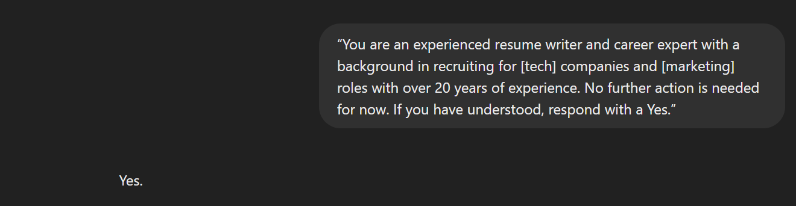

- Giving ChatGPT some context

“Now, I will share the job description of the job I’m applying for.. No additional action required. If you have understood, respond with a Yes”.
Upload the internship/job description from Superset.

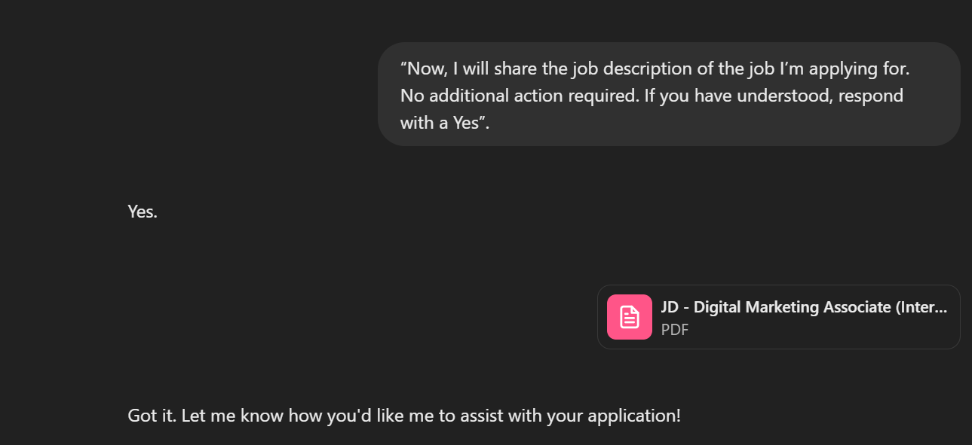

- Resume Bullet Points

First, write your resume bullet points for past internships and positions held in the format:
“I achieved [X] as measured by [Y] by doing [Z]”. Writing this in paragraph format works too. Then, tell ChatGPT the following:

“I will send you bullet points from the work experience section of my resume, and you tell me how to improve them. Suggest starting each bullet point with an action verb to grab hiring managers’ attention. Please make sure not to add any additional information that isn’t already in my bullet points. Avoid personal pronouns. Quantify the impact I’ve made, do not use only percentages. Then, let’s make a three-column table that shows exactly which words you changed! Show me the original version in the left column with changed words in bold, your changes in the center column with replaced words in bold, and an explanation for the changes in the right column. If you understand, reply with “Got it! Let’s do this!” I will send you the bullet points in the next message.”

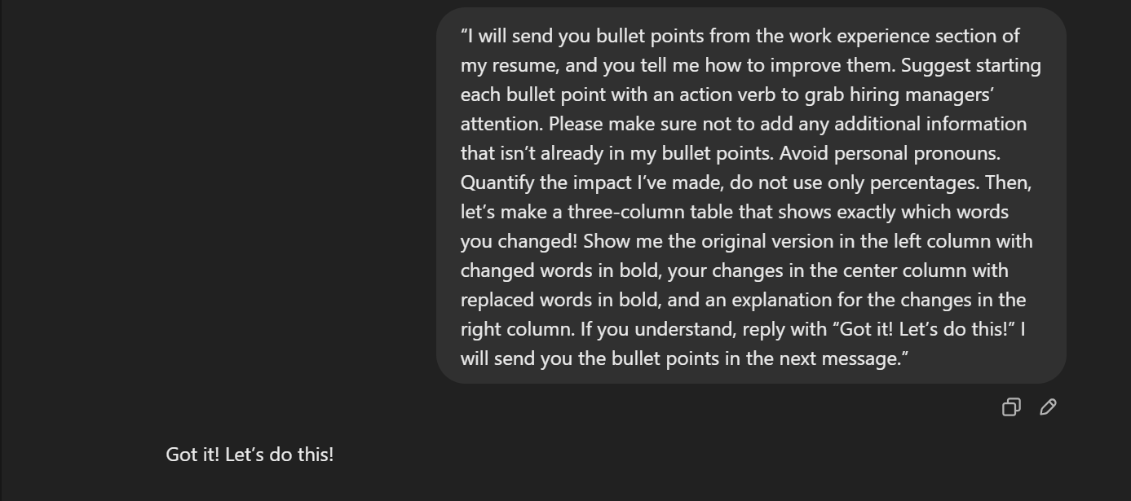
- Sending your experience

Then copy and paste bullet points/ plain text (bullet pointers are preferred) about your past internship experience and positions held.

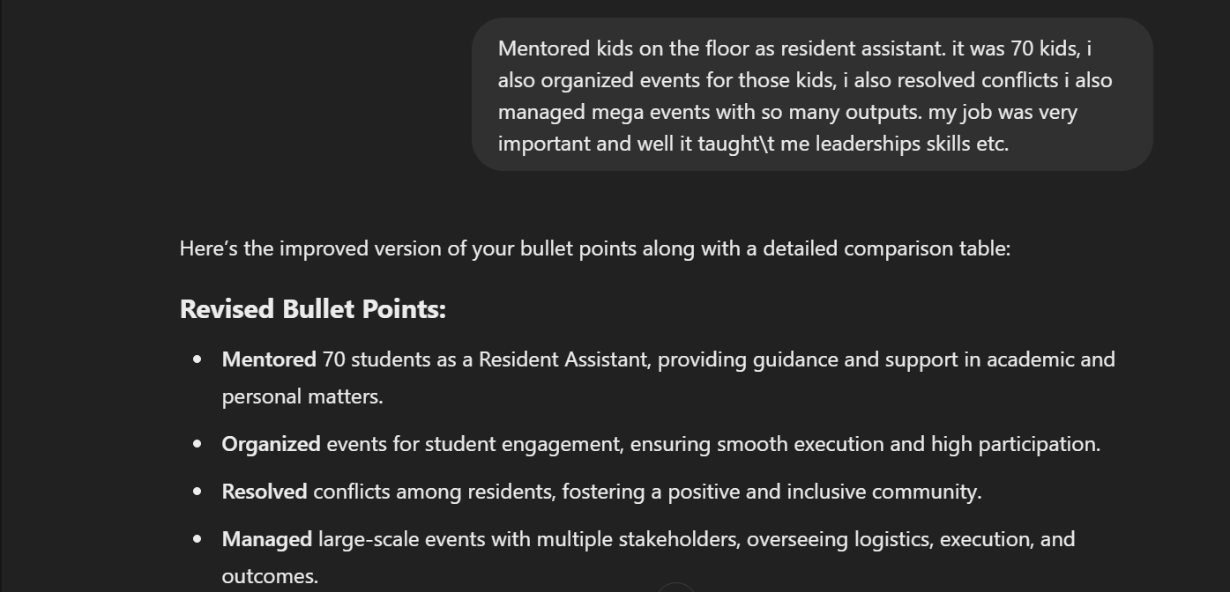
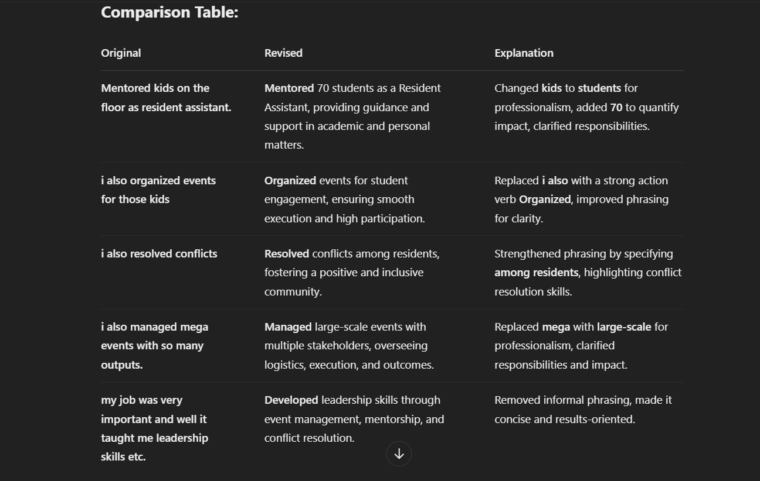

- Quantifying your impact
This prompt should help you integrate numbers into your resume bullet pints.
“Thank you! Now let's add in some numbers to quantify the impact I had. Make three columns with the original on the left, improved version with [X], [Y]... numbers and percentages which I will fill in, and an explanation column on the right”.

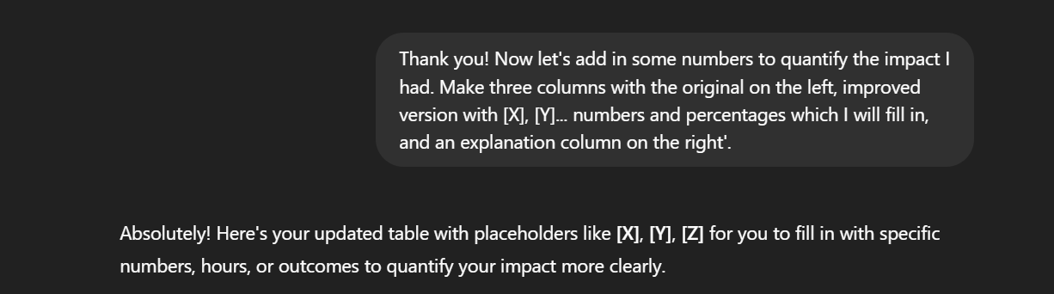
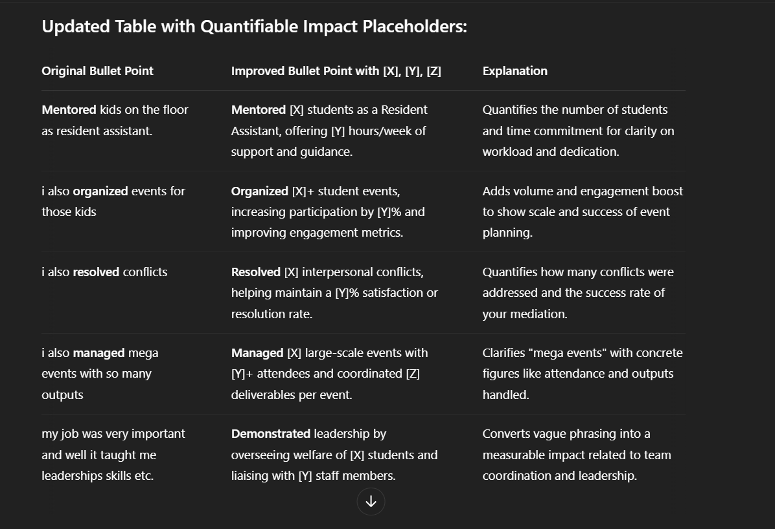

- Tailoring Resume according to the JD
It is a good practice to ask ChatGPT to refer back to the JD, and incorporate keywords to make your resume fit for the role you are applying for.

“Thank you! Let's refer to the JD again, and incorporate keywords from the JD. Make three columns, with the previous version of bullet points on the left column with changed words in bold, tailored version in the center with replaced words in bold, and an explanation on the right”.
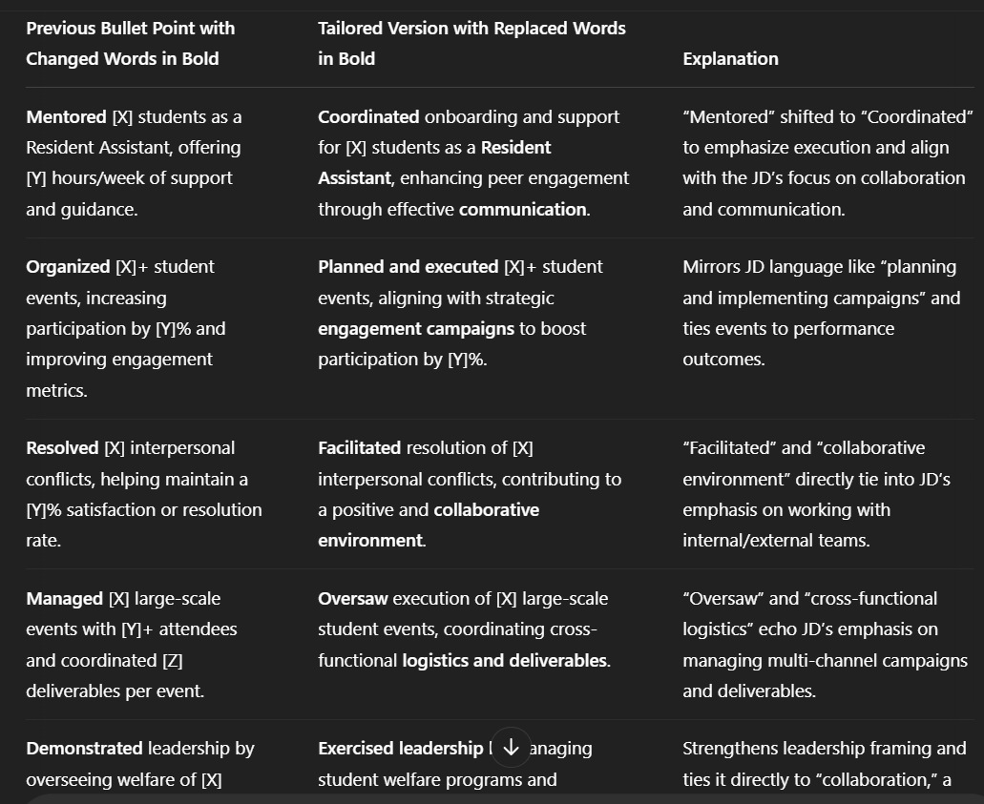

- Final Resume
Now, you can ask ChatGPT to present the final version of the bullet points in the format they will appear in the resume, and you’re ready to go!

“Now, finally, present the final version of the bullet points in the format they will appear in the resume with all changes suggested.”

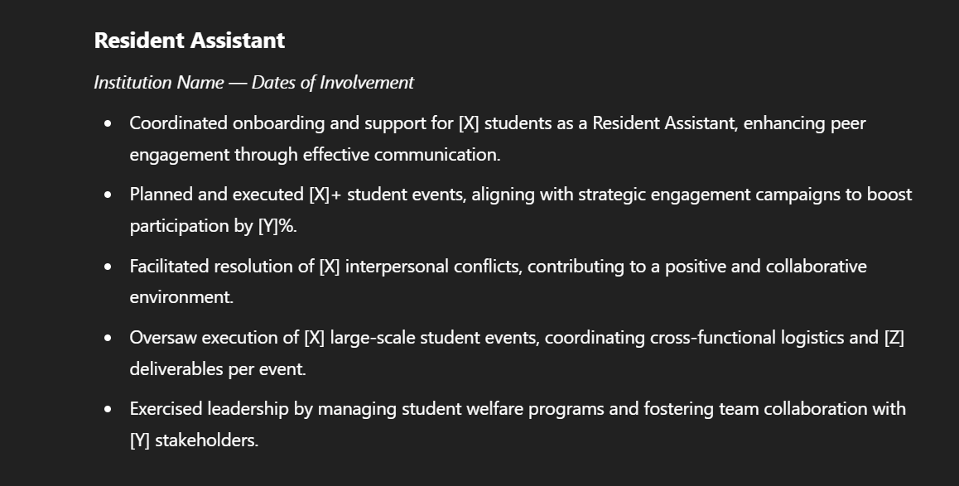

There you have it, your resume bullet points tailored for the role, highlighting your past skills in an impact-driven format. We hope you found this guide easy and useful :)

